**Report: Installation of Biometric System on Hillcom Door for Housing Client Equipment**

**Date of Installation:** 14th/12/2024  
**Location:** Hillcom Building – Housing Client Equipment Area  
**Installer(s):** Hillary and Blaize  
**Client:** Roke Telecom

**1. Objective:**

The purpose of this installation was to implement a biometric access control system for a secure entry solution on the designated Hillcom door, incorporating necessary wiring and components to ensure the system's functionality.

**2. Scope of Work:**

The installation involved several stages, including physical setup, cable laying, and system connections. Below is a detailed breakdown of the tasks performed:

**3. Installation Procedure:**

**3.1 Drilling of Holes:**

* **Objective:** Create passageways for cable pipes.
* **Action Taken:** Drilled holes through the walls to facilitate the passage of cable pipes from Hillcom’s upper floor to the lower floor. Care was taken to ensure no structural damage to the building, with all drill points accurately marked before proceeding.

**Images**

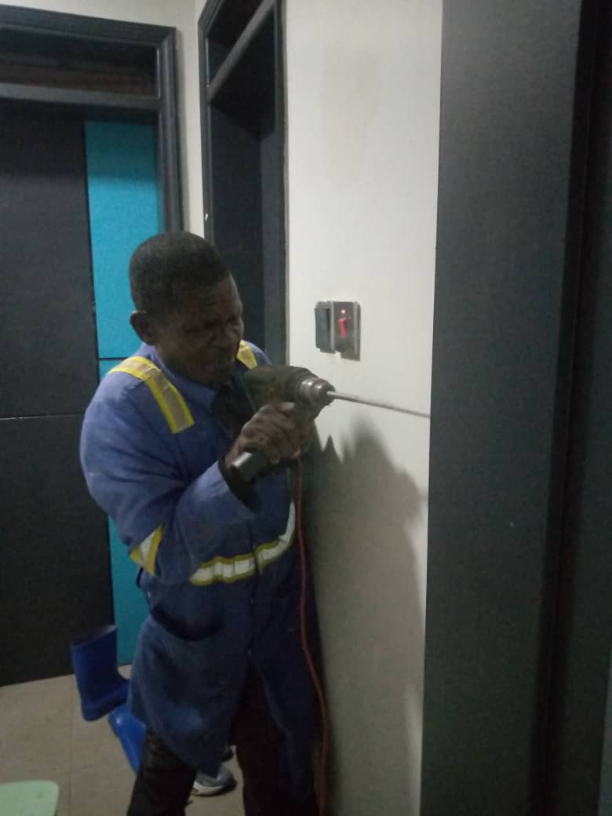

**3.2 Laying Ethernet and Power Cables:**

* **Objective:** Establish communication and power supply for the biometric system.
* **Action Taken:** Ethernet and power cables were carefully laid through the vent system from the upper floor to the ground floor. Proper cable management techniques were employed to prevent tangling and to ensure ease of future maintenance.

**3.3 Inserting Wall Brackets for Cable Pipes:**

* **Objective:** Secure the cable pipes and ensure stability.
* **Action Taken:** Wall brackets were mounted on the ceiling to hold the cable pipes securely in place. The brackets were positioned to minimize visibility and maintain a clean, professional look in the installation area.

**Images**

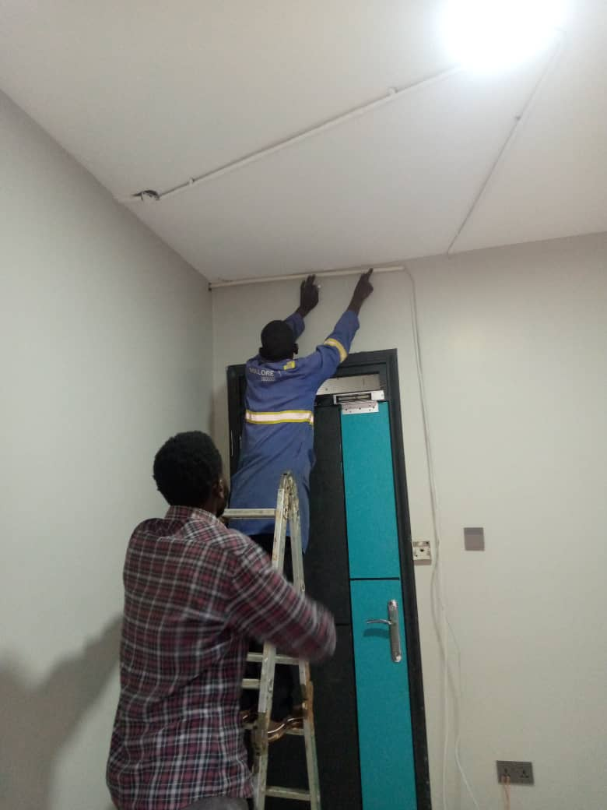

**3.4 Installing Biometric System and Exit Button:**

* **Objective:** Install access control hardware on the door.
* **Action Taken:** The biometric system and exit button were mounted on the designated wall, ensuring they were placed at an appropriate height for user access. The installation was done with precision to ensure that the components were aligned for optimal performance.

**Images**

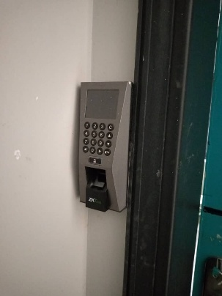

**3.5 Magnetic Lock Bar and Z-Brackets Installation:**

* **Objective:** Install magnetic lock for secure door entry.
* **Action Taken:** The magnetic lock bar was mounted at the upper side of the door. Z-brackets were attached to the door frame to secure the lock mechanism in place, ensuring the door can be effectively locked and unlocked via the biometric system.

**Images**

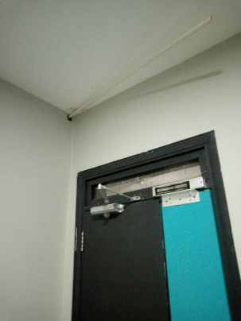

**3.6 Power Supply Connections:**

* **Objective:** Ensure proper power supply for the system.
* **Action Taken:** The power supply cable was connected from the Hillcom ground floor to the power supply unit. All cables were securely fixed to prevent damage or interference with other systems.

**3.7 Ethernet Cable Termination:**

* **Objective:** Ensure proper data connection for biometric system.
* **Action Taken:** The Ethernet cable was terminated at both ends to establish a stable network connection for the biometric system. Necessary connectors and tools were used to ensure a secure and functional termination.

**3.8 System Connections (Magnetic Lock, Biometric, Exit Switch):**

* **Objective:** Ensure the full integration and functionality of the system.
* **Action Taken:** All system components (magnetic lock, biometric system, and exit switch) were connected and tested. The biometric switch was successfully integrated with the other components, ensuring the system works as intended for door access control.

**4. Testing and Verification:**

* **Objective:** Ensure system functionality and security.
* **Action Taken:** After all physical installations and connections were made, the biometric system was tested for proper operation. The following checks were performed:
  + Biometric system recognized authorized users.
  + Exit button and magnetic lock functioned as expected.
  + Ethernet and power connections were stable, with no disruption to the system's operation.

**5. Conclusion:**

The installation of the biometric system on the Hillcom door was completed successfully, with all components securely in place and functioning as intended. The system now offers secure access control for the client, with all wiring and components professionally installed and tested.

The installation was completed on time and within the agreed-upon specifications, and the client has been provided with instructions for ongoing maintenance and operation of the system.

**Installer(s):**  
Hillary  
  
**Date:** 14/12/2024